Task 3: Jira Board Setup, User Stories and Story Points

-2420090145(N.Pardheev)
Aim: To create a Scrum project in Jira, define five user stories, assign story points, create a sprint, and manage work using a Scrum Board.

Step 1: Create a Jira Account
- Go to https://www.atlassian.com/software/jira
- Click Get it Free or Sign Up.
- Create an Atlassian account and verify your email (Domain Mail Id Only).
- Log in to Jira.
(This step was completed directly by the user for account security purposes.)

Step 2: Create a Scrum Project
Create a Software project using the Scrum template. Give the project a name such as 'My Software Team'.

Selecting the Scrum template
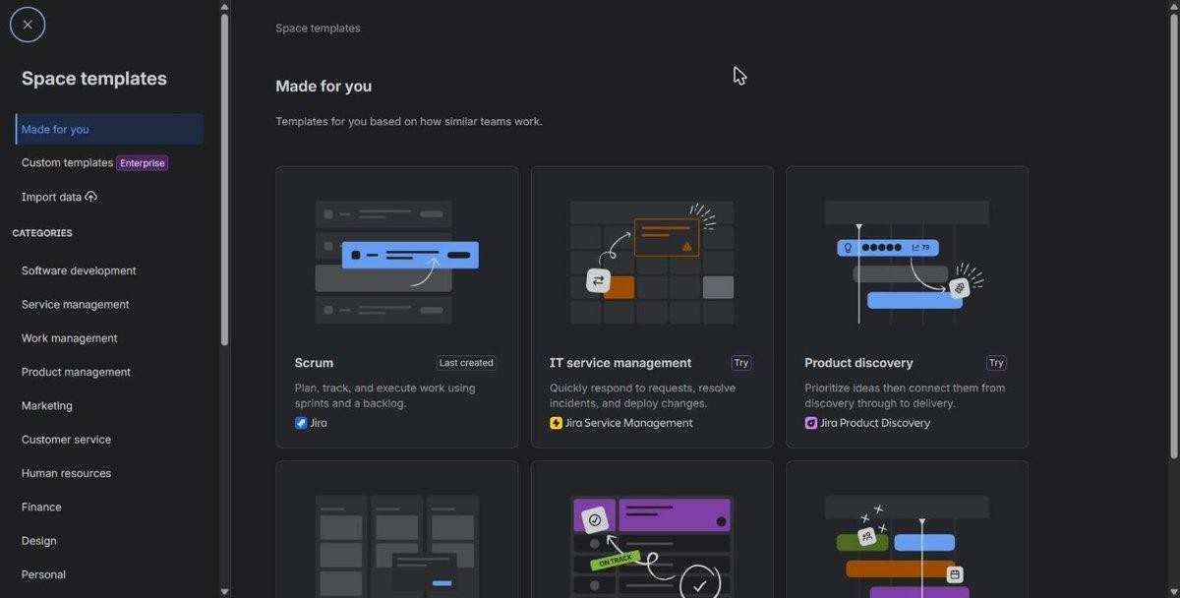

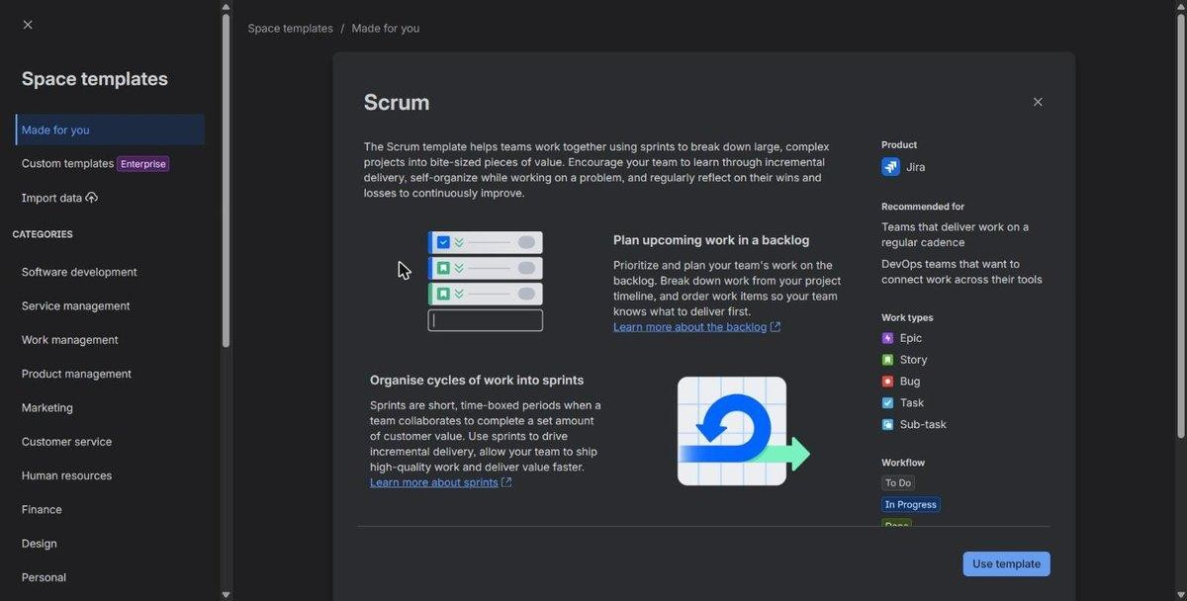

Naming the project
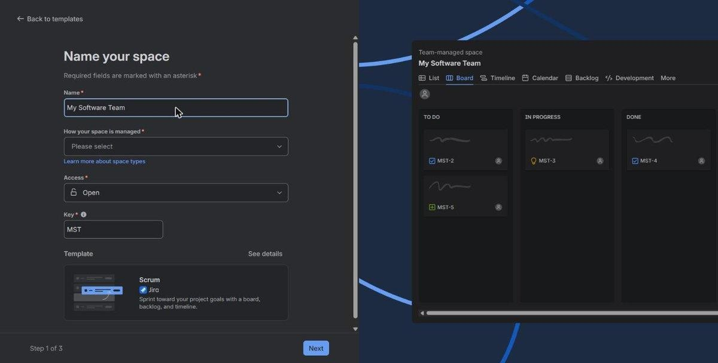

Result: Project created
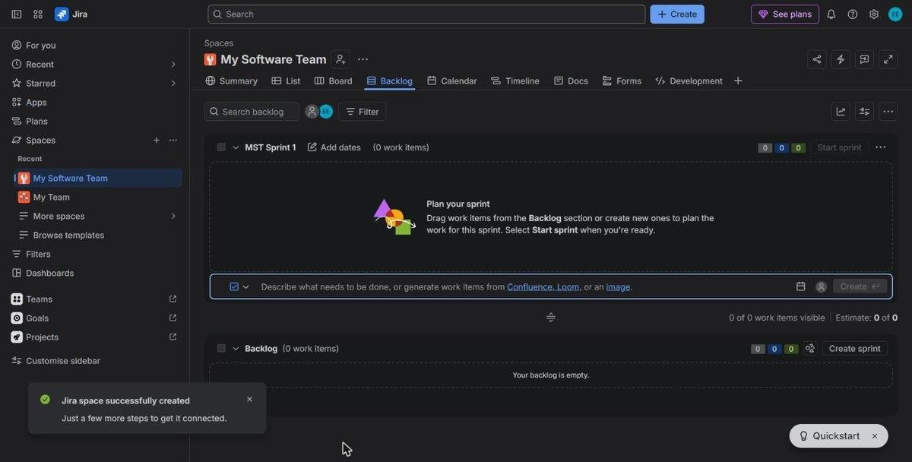

Step 3: Select Work Types
Select Story and Task as work types. Stories represent user requirements.
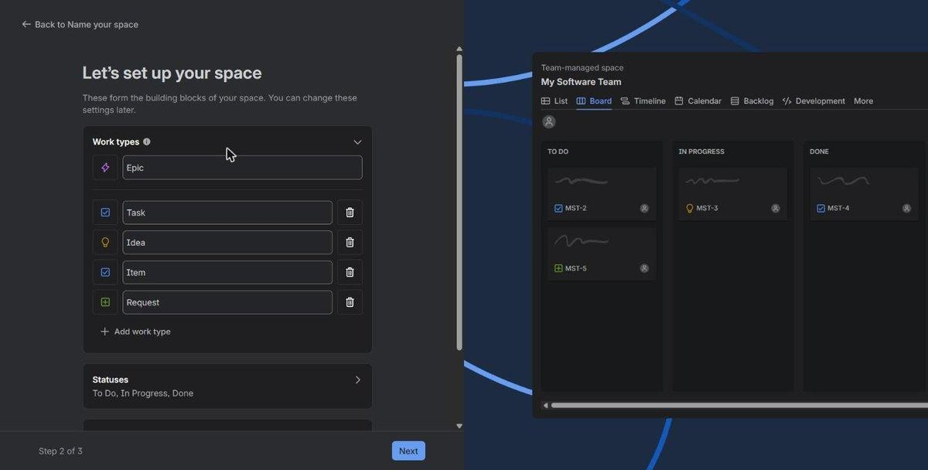
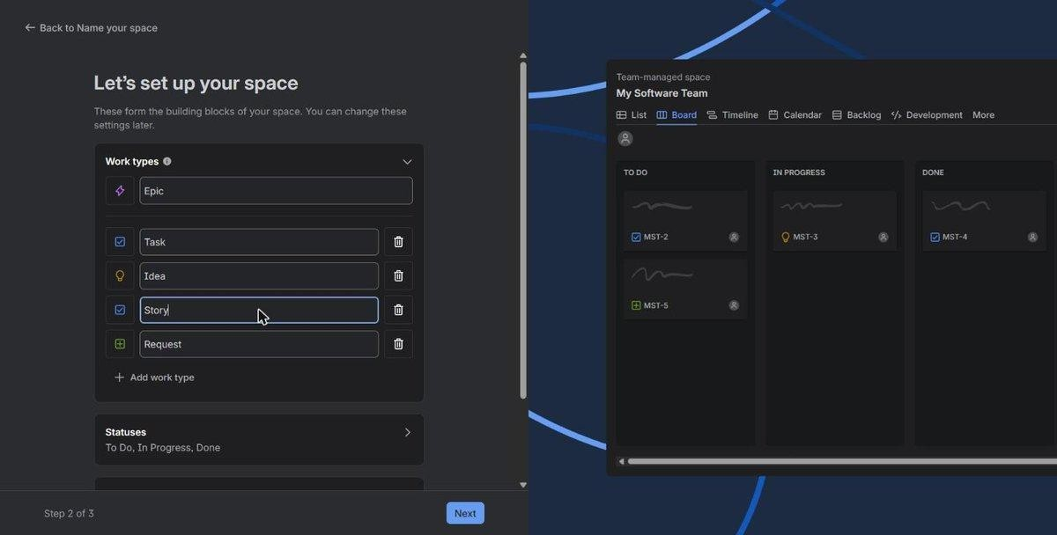

Step 4: Configure Workflow
Keep the default workflow: To Do → In Progress → In Review → Done.

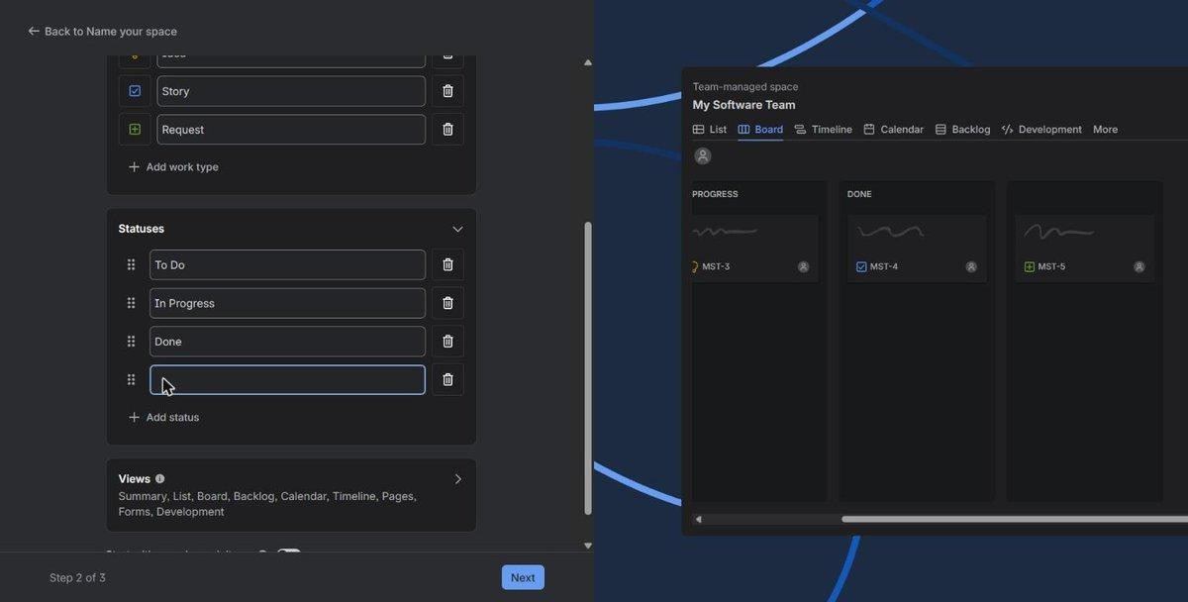
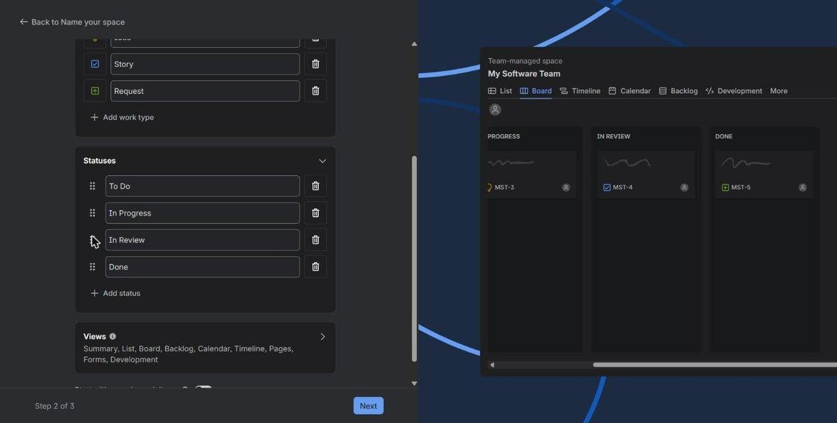

Step 5: Skip Team Invitation
Skip inviting teammates and proceed to Jira.

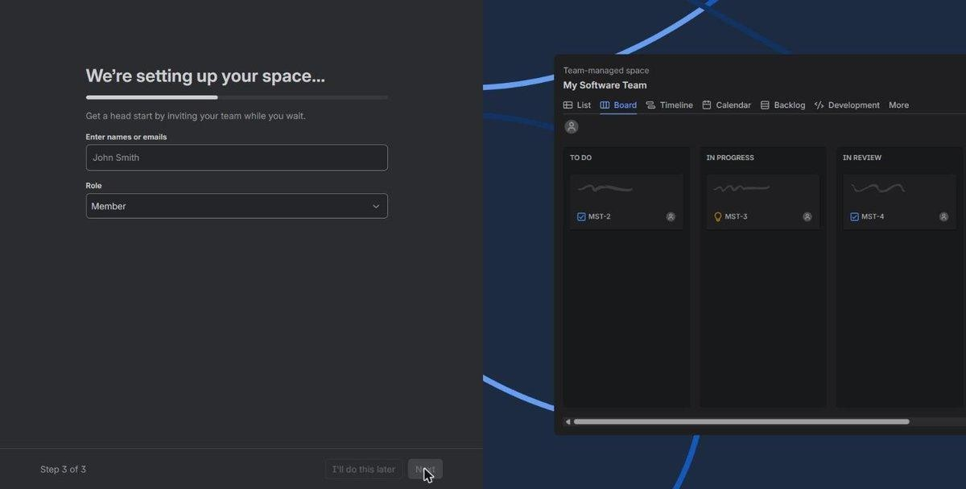

Step 6: Create User Stories
Create five stories:
- Student Login
- Course Registration
- View Attendance
- Faculty Enter Marks
- View Results
After clicking "Go to Jira" you should see your project dashboard. Go to Backlog from the left navigation menu, then click Create (top menu or in the backlog) to add each story.

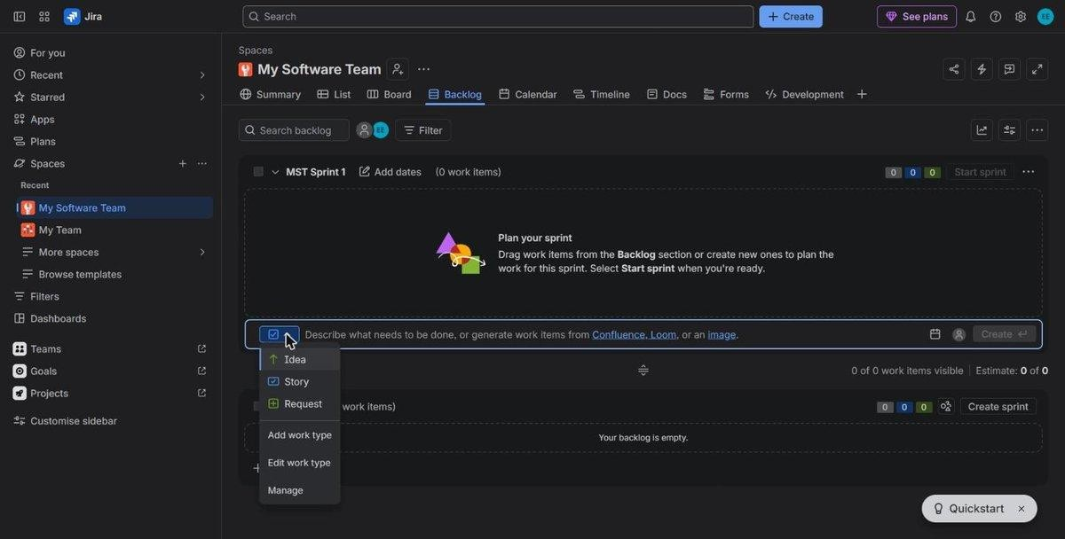
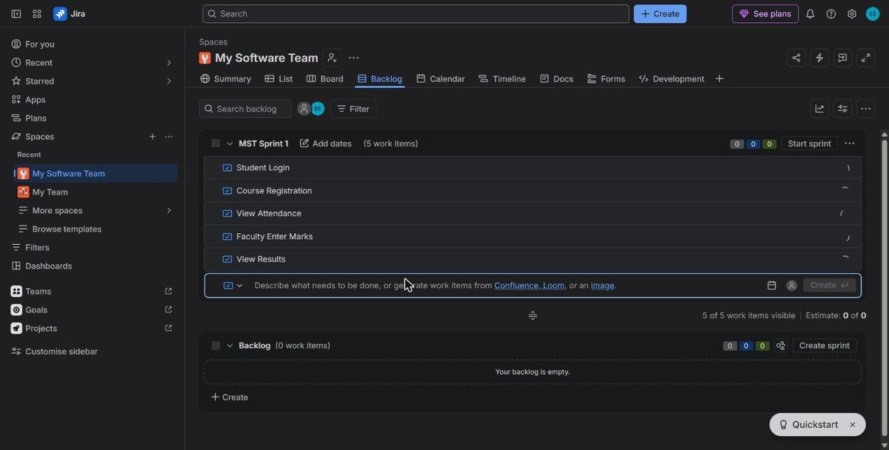

Step 7: Assign Story Points
Assign story points using Fibonacci estimates:

Summary | Story Points
Student Login | 3
Course Registration | 5
View Attendance | 2
Faculty Enter Marks | 5
View Results | 3

Story 1 — Student Login
Summary: Student Login

Description:
As a student,
I want to log in securely,
So that I can access my academic information.
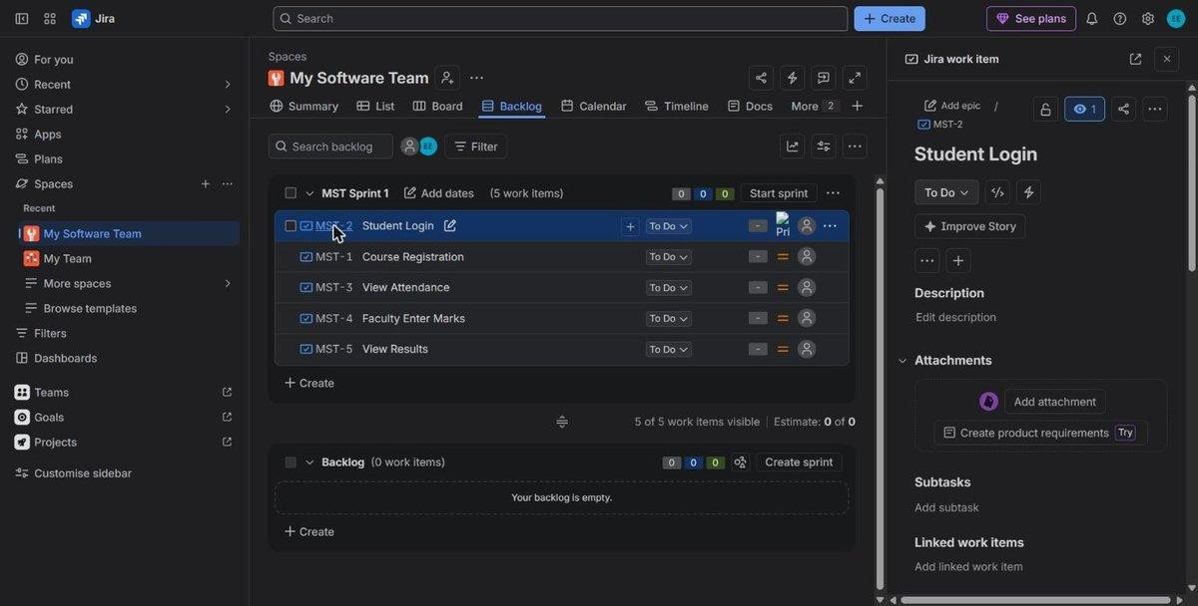
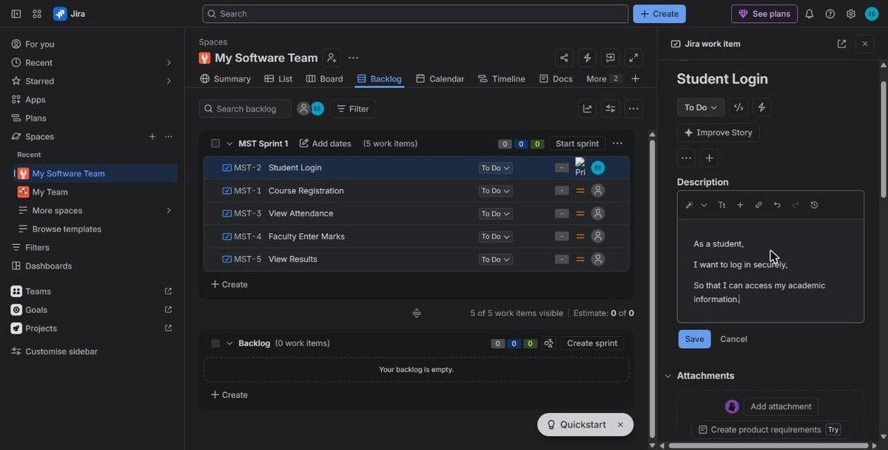
Status: To Do (left as default) Story Point Estimate: 3 Priority: Medium (default) Reporter: Default

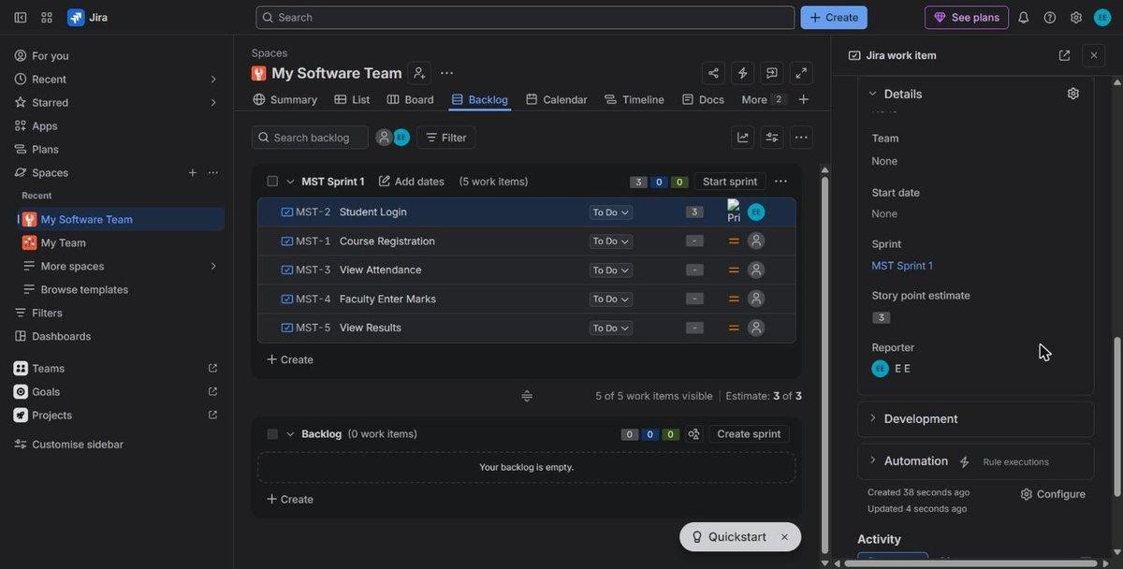

Story 2 — Course Registration Summary: Course Registration Description:
As a student,
I want to register for courses,
So that I can enroll in my subjects.

Story Points: 5

Story 3 — View Attendance Summary: View Attendance Description:
As a student,
I want to view my attendance,
So that I can monitor my academic progress.

Story Points: 2

Story 4 — Faculty Enter Marks Summary: Faculty Enter Marks Description:
As a faculty member,
I want to enter student marks,
So that students can view their academic performance.

Story Points: 5

Story 5 — View Results Summary: View Results Description:

As a student,
I want to view my examination results, So that I can evaluate my performance.
Story Points: 3

All five stories with story points assigned
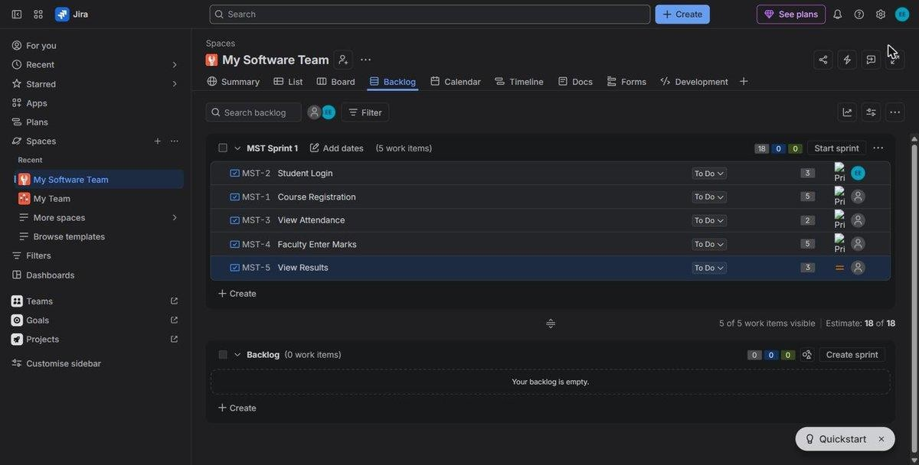

Step 8: Verify Product Backlog
Ensure all five stories appear in the backlog.

Step 9: Create Sprint
Create SCRUM Sprint 1 and move all stories into the sprint.
Sprint Goal: Implement student login, course registration, attendance viewing, faculty marks entry, and result viewing.

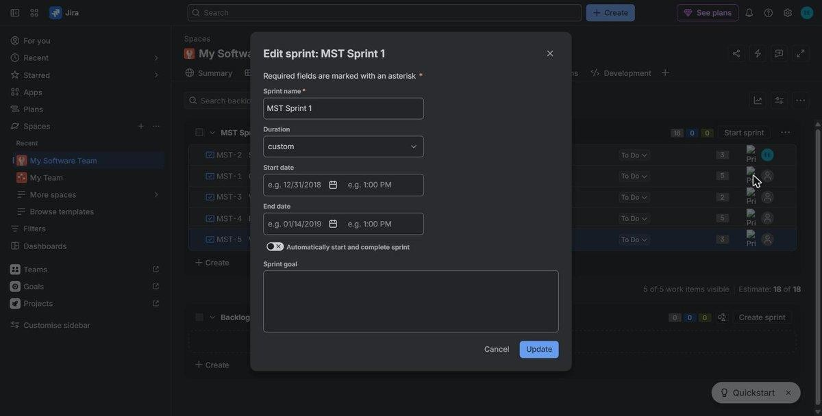
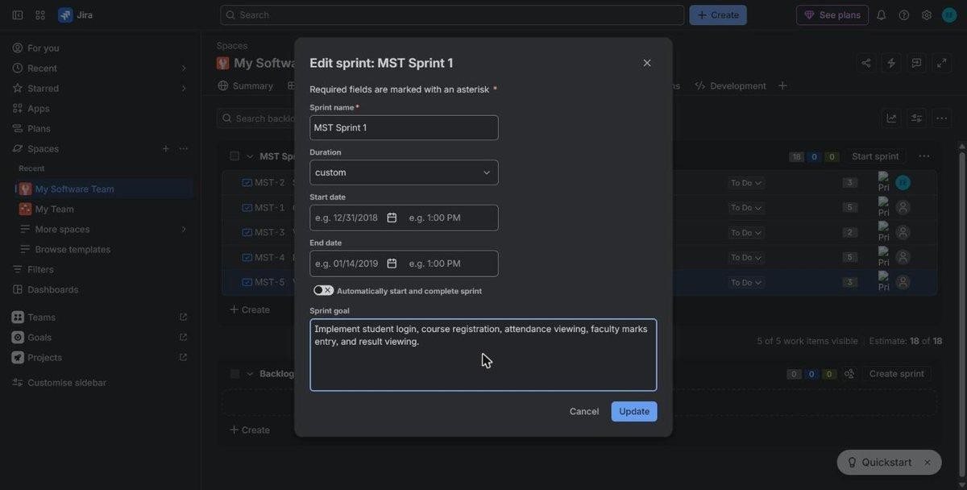
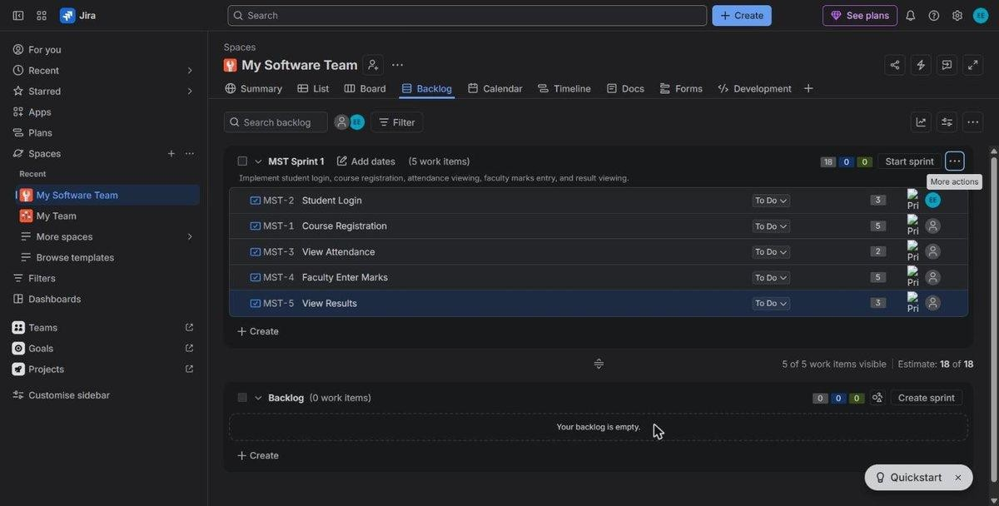

Step 10: Start Sprint

Start Sprint 1 with the default duration.
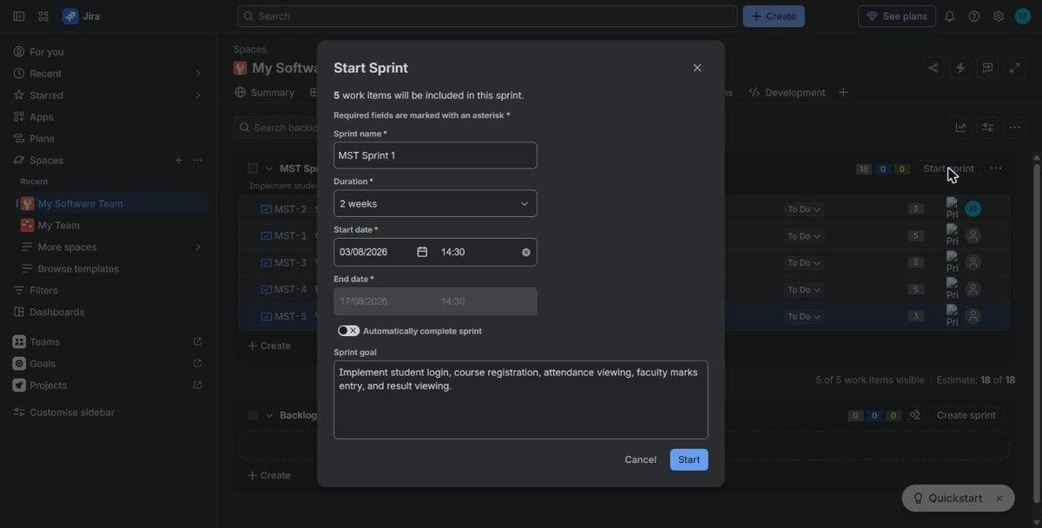
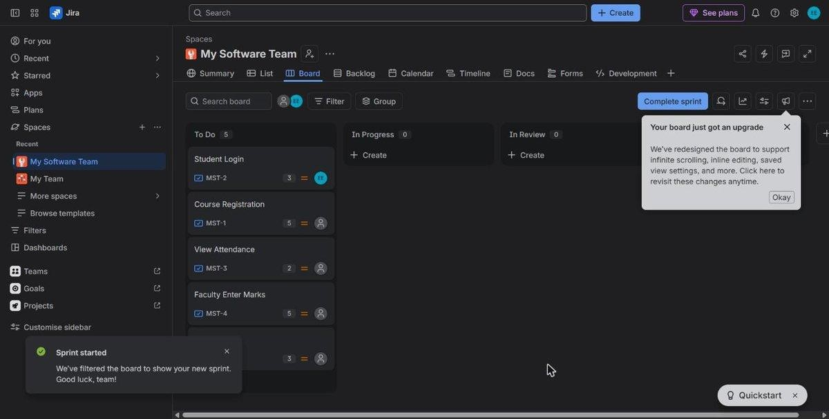

Step 11: Scrum Board
Verify that all five stories are displayed in the To Do column on the Scrum Board.

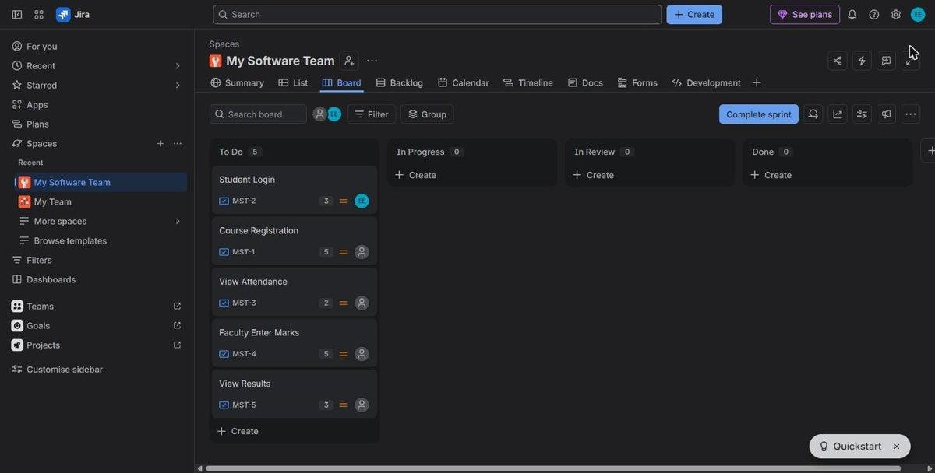

Result
Successfully created a Jira Scrum project, defined five user stories, assigned story points, created Sprint 1, and managed the stories using the Scrum Board.

